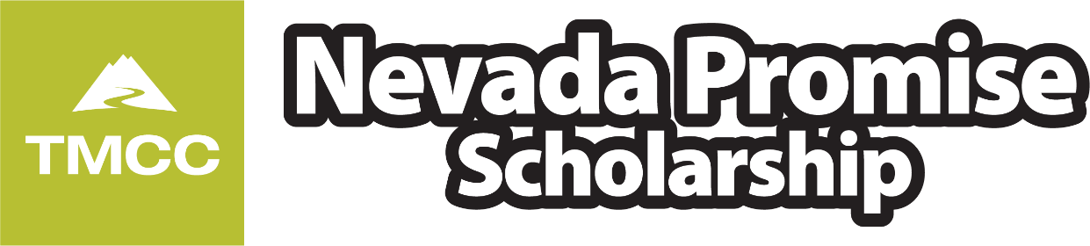

Hello Nevada Promise Candidates!

When you have an upcoming deadline, or if we learn about community service opportunities in the area, or even if we simply have information we feel is important to share with you, we will email you through this ListServ. Please do not reply to these emails as it is meant for sending emails only. If you have questions about your scholarship application or an email we send out, please reply back to [nvpromise@tmcc.edu](mailto:nvpromise@tmcc.edu). Remember, you are required to monitor your email address for updates from Nevada Promise, or you risk losing the scholarship.

For most of you, the next required step is to complete the Nevada Promise Program Training. To learn more about this required training, see the relevant page [here](https://www.tmcc.edu/nevada-promise-scholarship/trainings). The deadline to complete the NPS training is March 1 and you can complete the training either in a live session (in person or on Zoom) or self-paced through our Canvas course, though that requires you apply to TMCC first so we can add you as a student there. Most students lose eligibility here, and we'd rather keep as many of you eligible as possible.

Many of you have not yet applied to TMCC as a degree seeking student, so please do that here: [apply.tmcc.edu](http://apply.tmcc.edu/). Remember that there are no upfront costs to apply to TMCC, and when applying, please do attempt to pick a degree pursuit that interests you. If you have no idea whatsoever, consider this:

* If you do not like math or are okay with taking 4 semesters of the same foreign language
  + Sign up for the Associate of Arts, general transfer degree.
* If you do not mind math or would rather not take 4 semesters of the same foreign language
  + Sign up for the Associate of Science, general transfer degree.

Make sure you enter your Social Security Number on [MyTMCC](http://my.tmcc.edu) if you've already applied but didn't have it at the time. Never email your SSN or other personally identifiable information.

Thanks for taking the time to read this. We're here if you have questions or concerns, and our contact information is in the email signature below. FYI, email tends to be best for us. Have a wonderful three day weekend!

Christopher Jones, MA

TMCC Nevada Promise Scholarship

Recruitment and Access Center

Truckee Meadows Community College

[7000 Dandini Blvd](https://maps.google.com/?q=7000+Dandini+Blvd&entry=gmail&source=g). RDMT 315

Reno, NV 89512

Office: 775-673-8236

Text: 775-243-4620

[nvpromise.tmcc.edu](http://nvpromise.tmcc.edu)

[nvpromise@tmcc.edu](mailto:nvpromise@tmcc.edu)